Level 23 -> Level 24

The goal of this level is to analyse a program that is running automatically at regular intervals from **cron**, the time-based job scheduler. We need to look in **/etc/cron.d/** for the configuration and see what command is being executed.

This level is similar to the level 22 & 23.

* Use cd /etc/cron.d/ to enter into this directory.
* Use ls to check for files and folder in current directory.
* Use cat to read the content of cronjob_bandit24 file. This is the file which consists the task cron is doing.

@reboot bandit22 /usr/bin/cronjob_bandit24.sh &> /dev/null

* * * * * bandit22 /usr/bin/cronjob_bandit24.sh &> /dev/null

**And cron is doing something in cronjob_bandit24.sh file in /usr/bin/ directory.**

* So, we will check in /usr/bin/ directory by entering into it using cd command.
* And using cat command read the content of cronjob_bandit24.sh file.

The script id doing something in /var/spool/$myname. It is executing all the scripts in /var/spool/$myname and then deleting them all after 60 sec.

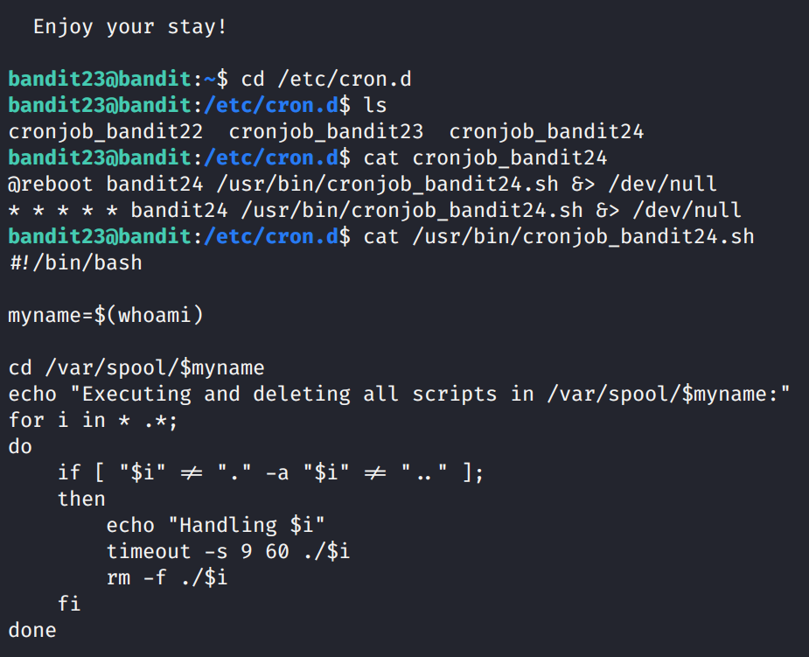

1. So, we need write our own script so that we can copy the password of the next level.
2. Following is the script that i have written:

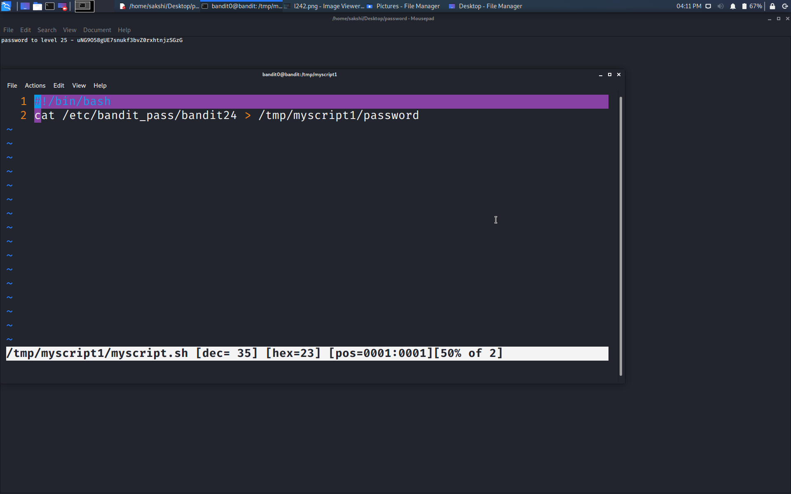

1. This script will copy the password of level 24 which is present in the /etc/bandit_pass/bandit24 to the password file in /tmp/myscript1 folder.
2. So, for doing this we need to create myscript1 folder in tmp directory.
3. We need to make a **.sh** file to write our bash script.
4. And then copy the script file into the **/var/spool/bandit24** directory.
5. Password file is not created by us but it will be created by automatically when the script run from the **cron**.
6. Now, we can just do is, check for the file named **password** using **ls** command repeatedly.
7. Hence, we got the file and read the content of the file using **cat** command and get the password.

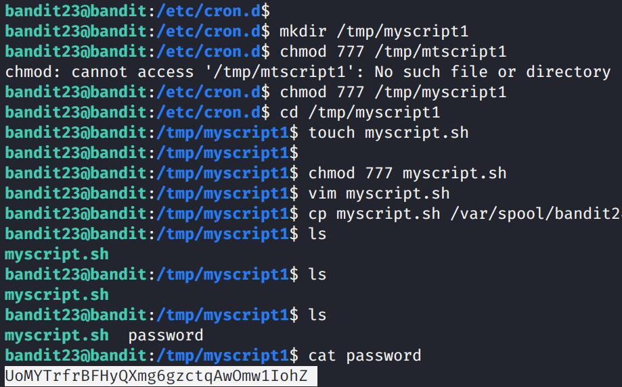

Use the command **ssh bandit24@localhost** to connect to the level 24.

Enter the password and hit enter.

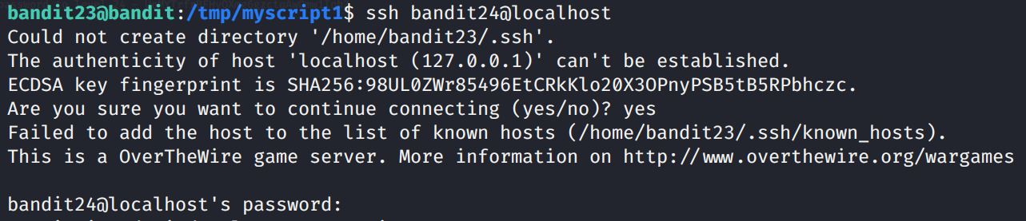

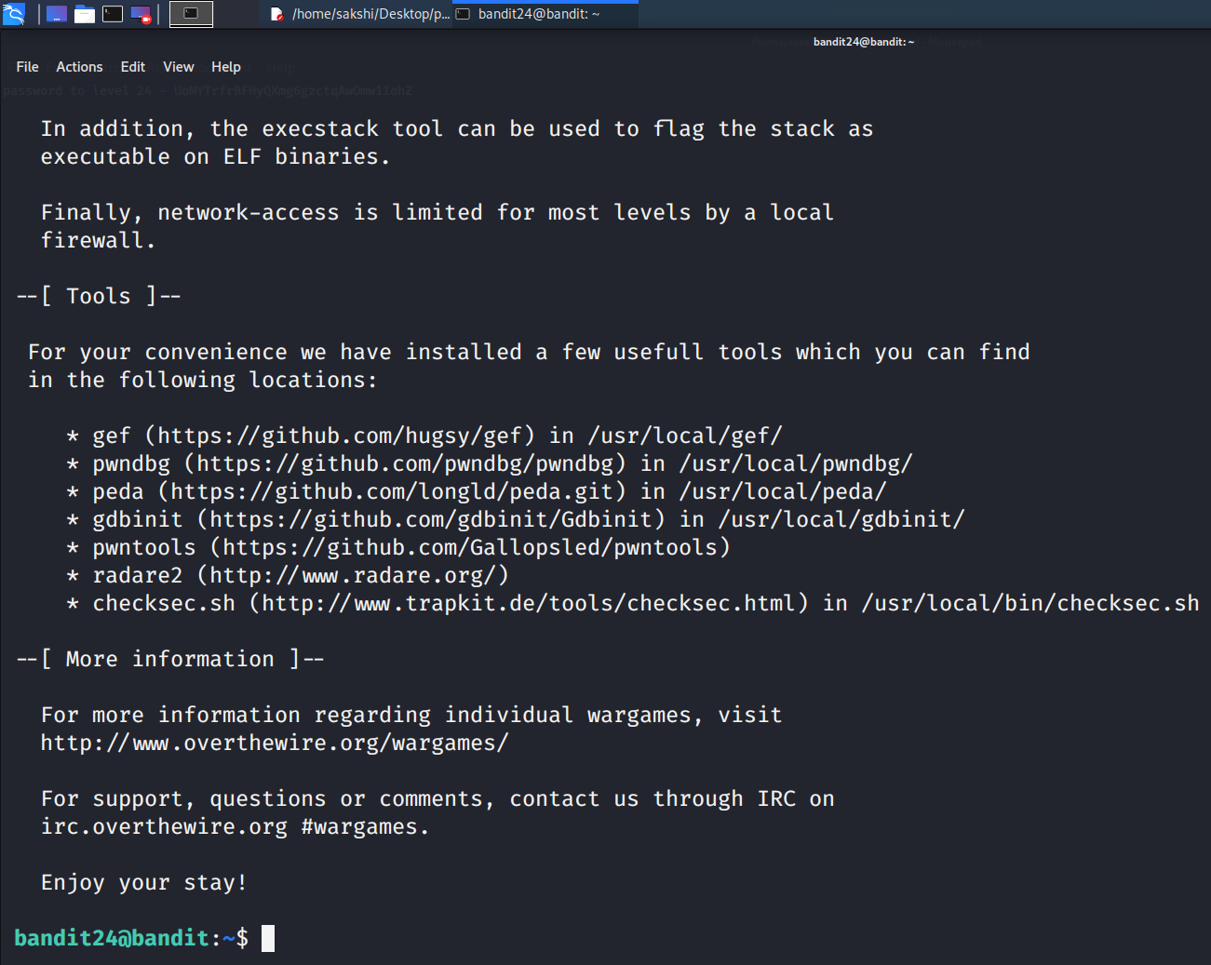

Successfully passed level 24.…